# Select an option, help today and get entered into any raffle you choose!

# A one-time donation will receive 1 drawing entry per $1.00

# 2 weeks Debit Card Roundup will receive 5 drawing entries

# 1 month Debit Card Roundup will receive 10 drawing entries

 One-time $ from my  Checking  Savings  VISA

 Debit Card Roundup for  2 weeks  1 month

Debit Card Roundup donates my change from each daily debit transaction for the time chosen.

I authorize my Debit Card Roundup or one-time donations to help Christmas for Kids in GH.

Name­­­___________________________­

Member Number__________-____

Signature_____________________Date__­­_____­­

# F6EE7D64-5F28-466D-9666-9815B43DFEC7.JPG E3861A34-9AE0-40F1-9C6A-0A30A29E46C9.JPG 13040459-7000-4ABB-8FE2-BF7F5F0F6361.JPG 828972EF-FC6F-4F87-B462-9092D89FCF11.JPG

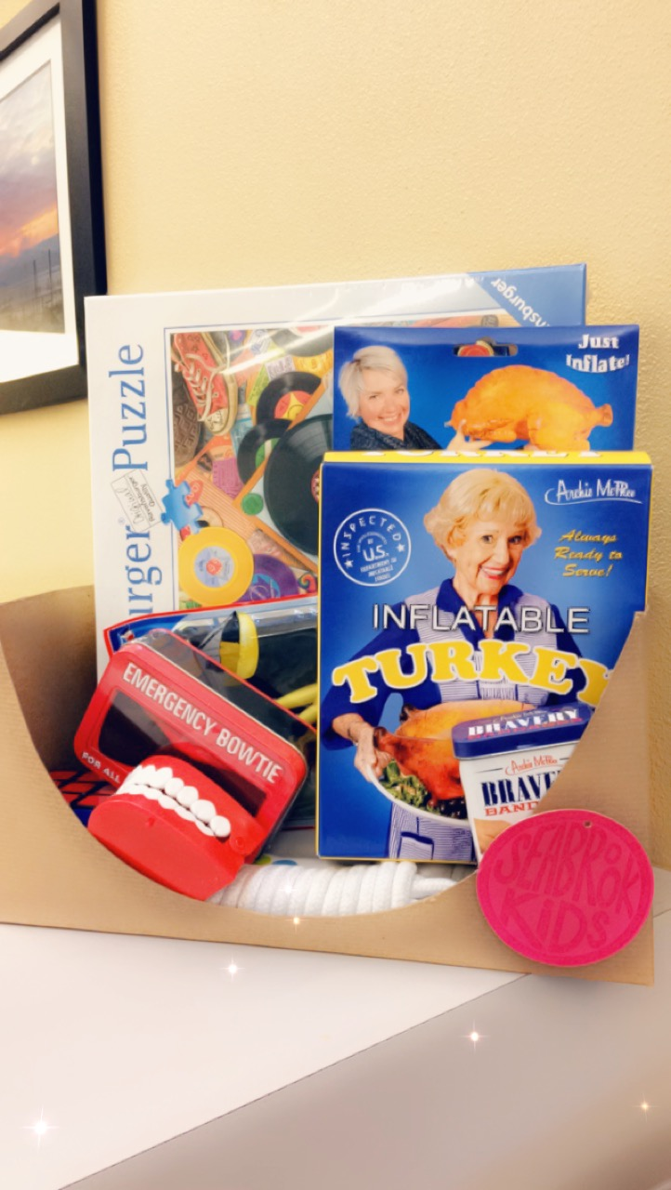 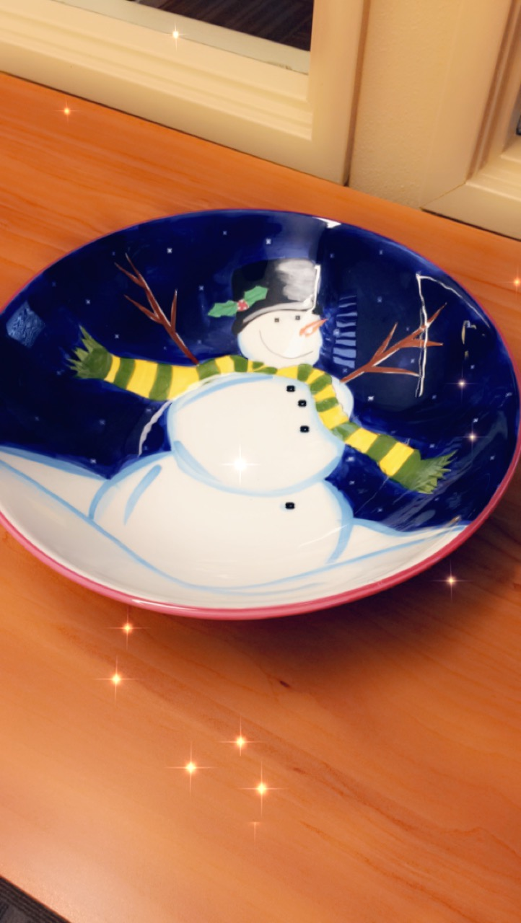 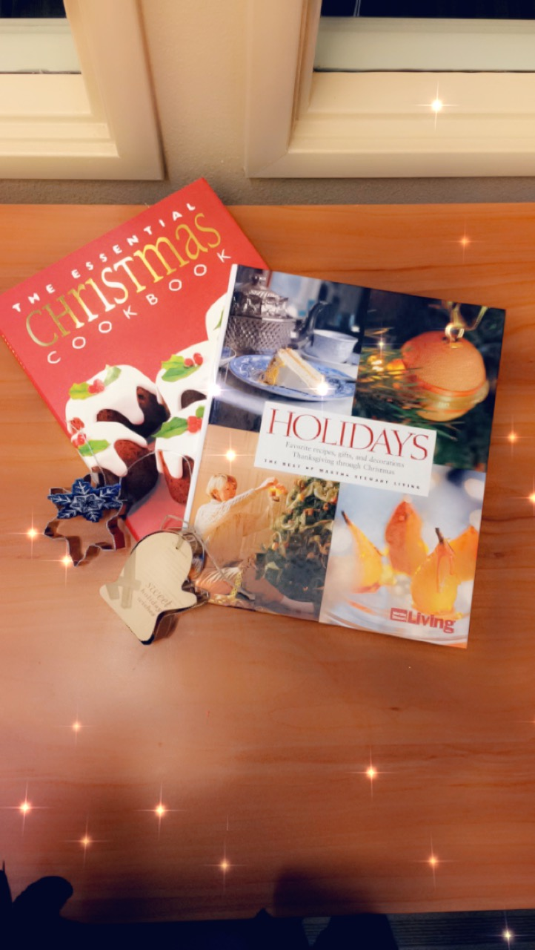

Help support **Christmas for Kids in Grays Harbor** today!

|  |
| --- |
| Snowflake background |